**GPA CALCULATOR USING JAVASCRIPT**

**Sample output:**

**gpa.html**

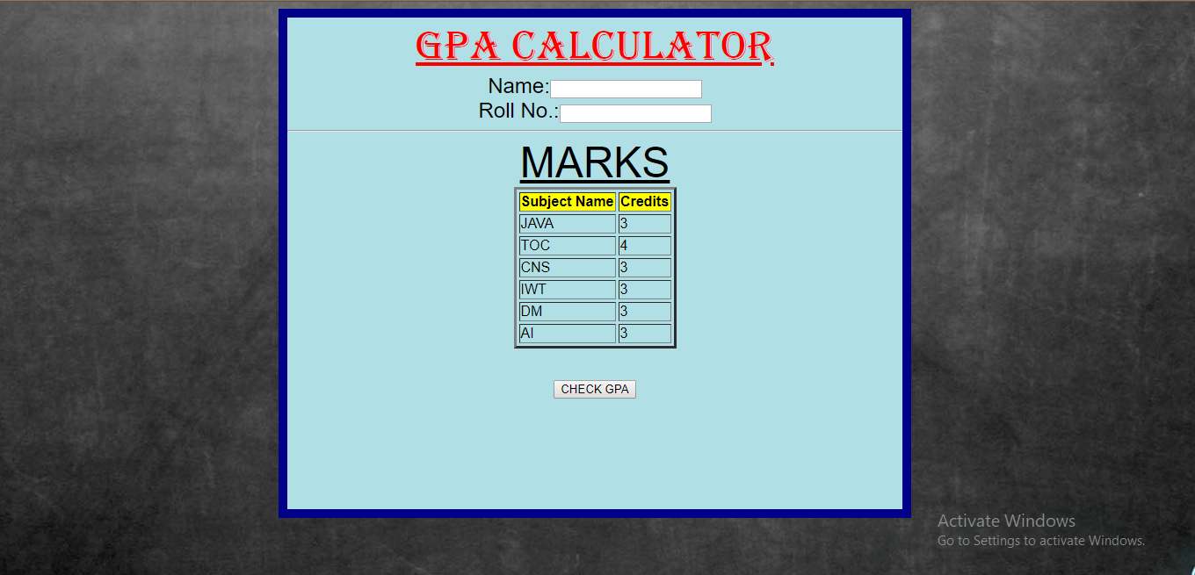

**gpa1.html**

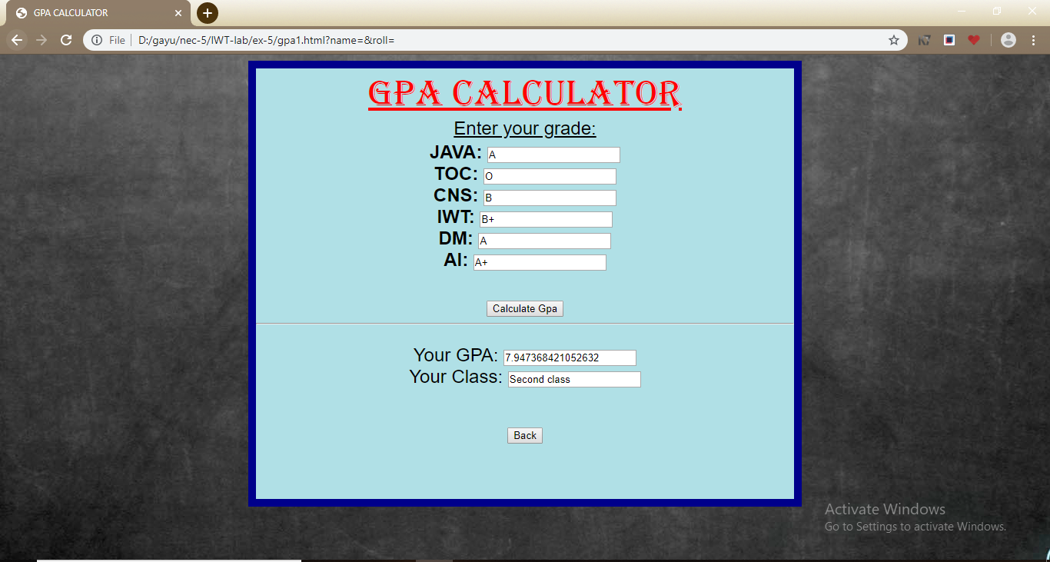

**gpa.html**

<html>

<head>

<title>GPA CALCULATOR</title>

<style>

div

{

width:700px;

height:560px;

border-width:10px;

border-color:darkblue;

border-style:solid;

}

</style>

</head>

<body>

<center>

<div style="background-color:powderblue" align="center">

<font face="Algerian" color="red" size="8"><u>GPA CALCULATOR</u></font>

<form name="gpa" action="gpa1.html">

<font face="Arial" color="black" size="5">Name:<input type="text" name="name"></font><br>

<font face="Arial" color="black" size="5">Roll No.:<input type="text" name="roll"></font><br>

<hr>

<font face="Arial" color="black" size="7"><u>MARKS</u></font><br>

<table border="3" cellspacing="3">

<tr bgcolor="yellow" ><th>

<font face="Arial" color="black" size="3">Subject Name</font></th>

<th><font face="Arial" color="black" size="3">Credits</font></th></tr>

<tr>

<td>

<font face="Arial" color="black" size="3">JAVA</font></td>

<td>

<font face="Arial" color="black" size="3">3</font></td>

</tr>

<tr>

<td>

<font face="Arial" color="black" size="3">TOC</font></td>

<td>

<font face="Arial" color="black" size="3">4</font></td>

</tr>

<tr>

<td>

<font face="Arial" color="black" size="3">CNS</font></td>

<td>

<font face="Arial" color="black" size="3">3</font></td>

</tr>

<tr>

<td>

<font face="Arial" color="black" size="3">IWT</font></td>

<td>

<font face="Arial" color="black" size="3">3</font></td>

</tr>

<tr>

<td>

<font face="Arial" color="black" size="3">DM</font></td>

<td>

<font face="Arial" color="black" size="3">3</font></td>

</tr>

<tr>

<td>

<font face="Arial" color="black" size="3">AI</font></td>

<td>

<font face="Arial" color="black" size="3">3</font></td>

</tr>

</table>

<br>

<br>

<button>

<onclick="gpa1.html">CHECK GPA</button>

</form>

</div>

</center>

</body>

</html>

**gpa1.html**

<html>

<head>

<title>GPA CALCULATOR</title>

<style>

div

{

width:700px;

height:560px;

border-width:10px;

border-color:darkblue;

border-style:solid;

}

</style>

<script language="JavaScript">

function calculategpa()

{

var j=document.gpa.subj.value;

var t=document.gpa.subt.value;

var c=document.gpa.subc.value;

var i=document.gpa.subi.value;

var d=document.gpa.subd.value;

var a=document.gpa.suba.value;

if(j=='O')

{

var j1=10*3;

}

else if(j=='A+')

{

var j1=9*3;

}

else if(j=='A')

{

var j1=8*3;

}

else if(j=='B+')

{

var j1=7*3;

}

else if(j=='B')

{

var j1=5*3;

}

else if(j=='RA')

{

var j1=0*3;

}

else

{

window.alert("give valid grade")

}

if(t=='O')

{

var t1=10*4;

}

else if(t=='A+')

{

var t1=9*4;

}

else if(t=='A')

{

var t1=8*4;

}

else if(t=='B+')

{

var t1=7*4;

}

else if(t=='B')

{

var t1=5*4;

}

else if(t=='RA')

{

var t1=0*4;

}

else

{

window.alert("give valid grade")

}

if(c=='O')

{

var c1=10*3;

}

else if(c=='A+')

{

var c1=9*3;

}

else if(c=='A')

{

var c1=8*3;

}

else if(c=='B+')

{

var c1=7*3;

}

else if(c=='B')

{

var c1=5*3;

}

else if(c=='RA')

{

var c1=0*3;

}

else

{

window.alert("give valid grade")

}

if(i=='O')

{

var i1=10*3;

}

else if(i=='A+')

{

var i1=9*3;

}

else if(i=='A')

{

var i1=8*3;

}

else if(i=='B+')

{

var i1=7*3;

}

else if(i=='B')

{

var i1=5*3;

}

else if(i=='RA')

{

var i1=0*3;

}

else

{

window.alert("give valid grade")

}

if(d=='O')

{

var d1=10*3;

}

else if(d=='A+')

{

var d1=9*3;

}

else if(d=='A')

{

var d1=8*3;

}

else if(d=='B+')

{

var d1=7*3;

}

else if(d=='B')

{

var d1=5*3;

}

else if(d=='RA')

{

var d1=0*3;

}

else

{

window.alert("give valid grade")

}

if(a=='O')

{

var a1=10*3;

}

else if(a=='A+')

{

var a1=9*3;

}

else if(a=='A')

{

var a1=8*3;

}

else if(a=='B+')

{

var a1=7*3;

}

else if(a=='B')

{

var a1=5*3;

}

else if(a=='RA')

{

var a1=0*3;

}

else

{

window.alert("give valid grade")

}

var res=(j1+t1+c1+i1+d1+a1)/19;

document.gpa.mark.value=res;

if(res>=9)

{

document.gpa.class.value="First class with Distinction";

}

else if(res>=8 && res<9)

{

document.gpa.class.value="First class";

}

else if(res>=7 && res<8)

{

document.gpa.class.value="Second class";

}

else if(res>=6 && res<7)

{

document.gpa.class.value="Third class";

}

else

{

document.gpa.class.value="RA";

}

}

</script>

</head>

<body background="b2.jpg">

<center>

<div style="background-color:powderblue" >

<font face="Algerian" color="red" size="8"><u>GPA CALCULATOR</u></font>

<form name="gpa">

<font face="Arial" color="black" size="5"><u>Enter your grade:</u></font><br><table><tr><th>

<font face="Arial" color="black" size="5">JAVA: <input type="text" name="subj"></font><br>

<font face="Arial" color="black" size="5">TOC: <input type="text" name="subt"></font><br>

<font face="Arial" color="black" size="5">CNS: <input type="text" name="subc"></font><br>

<font face="Arial" color="black" size="5">IWT: <input type="text" name="subi"></font><br>

<font face="Arial" color="black" size="5">DM: <input type="text" name="subd"></font><br>

<font face="Arial" color="black" size="5">AI: <input type="text" name="suba"></font></th></tr></table>

<br><br>

<input type="button" value="Calculate Gpa" onClick="calculategpa()"><br><hr>

<br>

<font face="Arial" color="black" size="5">Your GPA: <input type="text" name="mark"></font><br>

<font face="Arial" color="black" size="5">Your Class: <input type="text" name="class"></font><br>

<br>

<br></form>

<form action="gpa.html">

<button onclick="gpa.html">Back</button>

</form>

</div>

</center>

</body>

</html>